Assignment 1 – Web Designer

Name: Thiago Maia.

Student Number: B00107943.

Teacher: [Nicola Duffy](https://moodle.itb.ie/user/view.php?id=1210&course=1).

WEBSITE ADDRESS: https://crazycast.github.io/aboutdublin/

As requested I`m attaching the screenshots from my “GitHub”:

# <https://crazycast.github.io/aboutdublin/index.html>

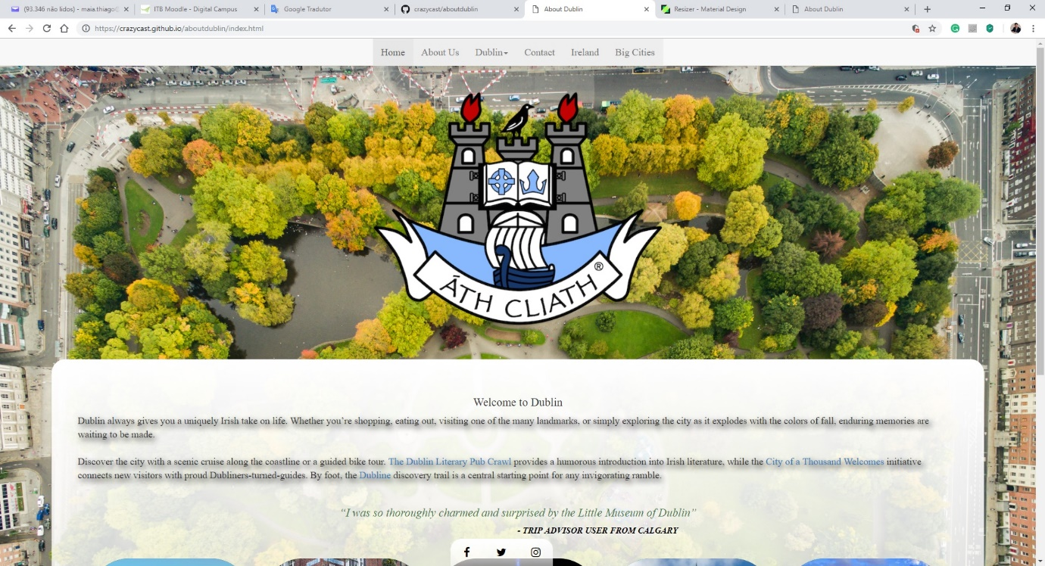

# <https://crazycast.github.io/aboutdublin/about.html>

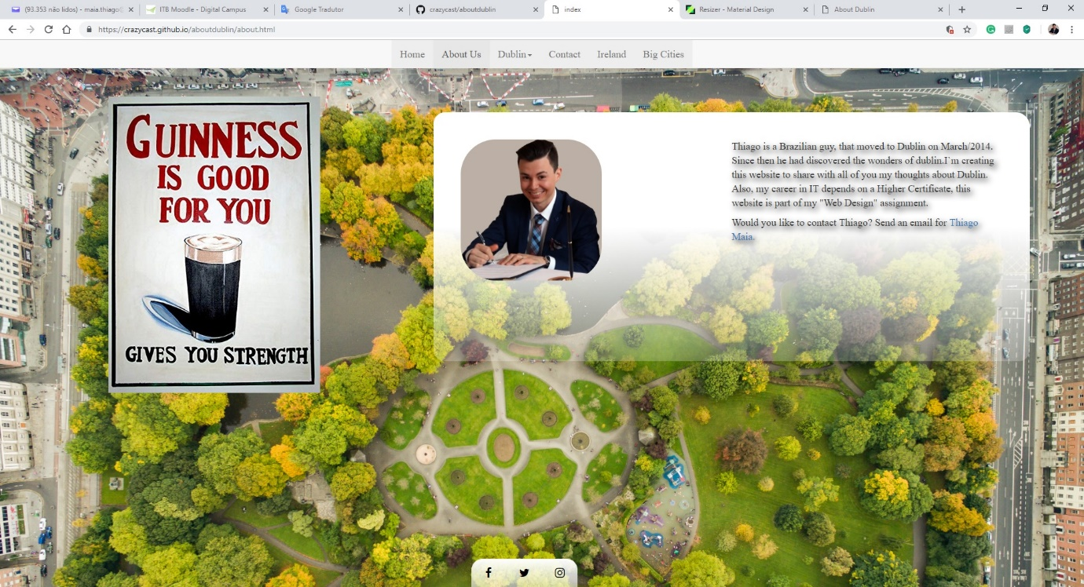

# <https://crazycast.github.io/aboutdublin/monuments.html>

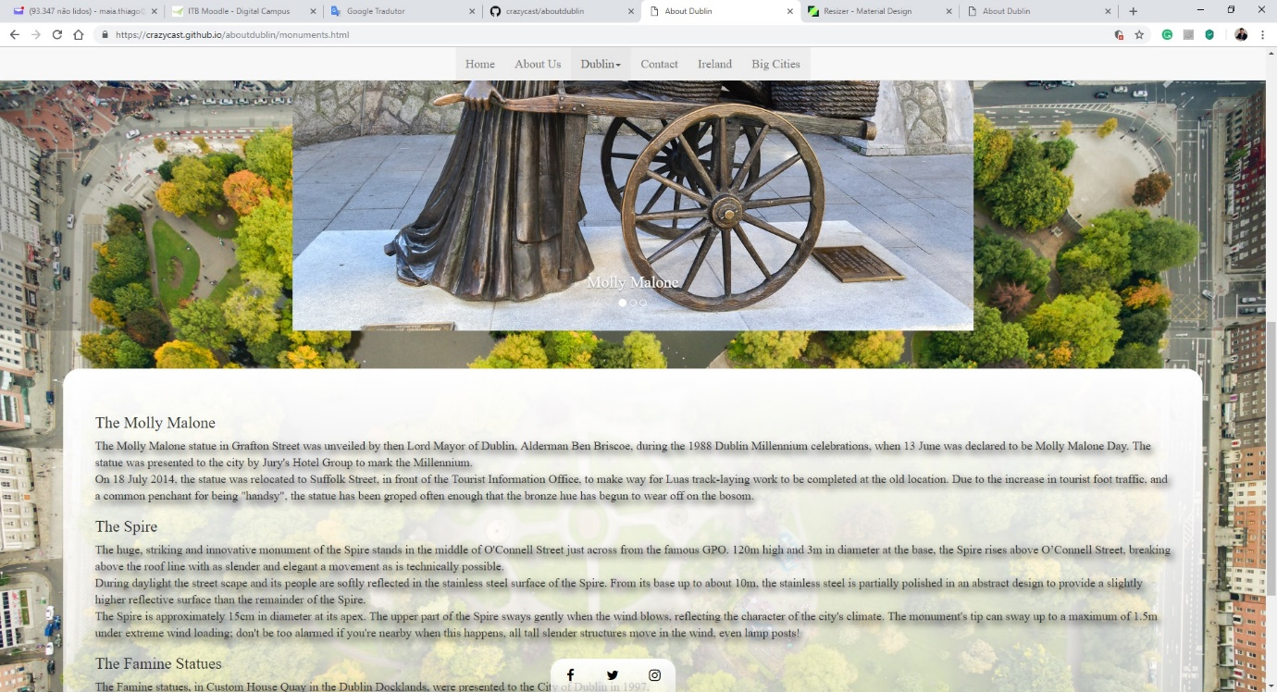

# <https://crazycast.github.io/aboutdublin/parks.html>

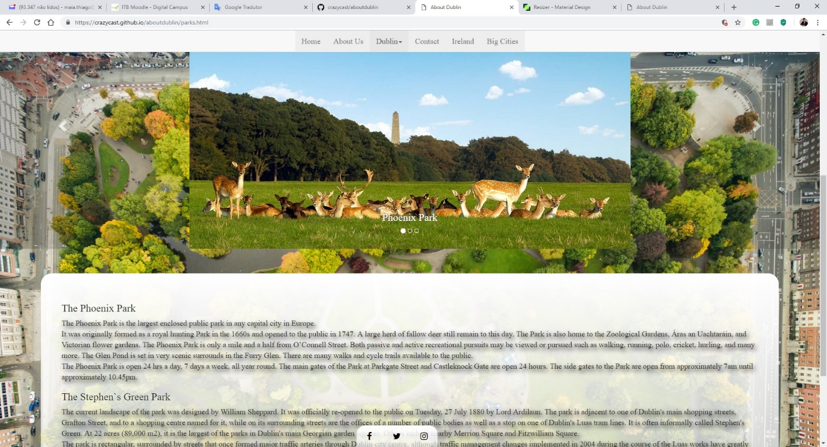

# <https://crazycast.github.io/aboutdublin/pub.html>

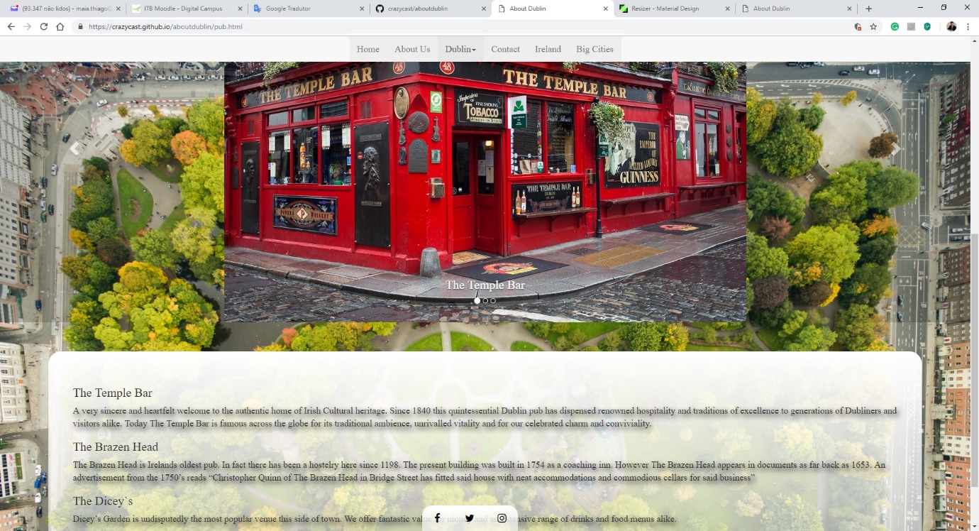

# <https://crazycast.github.io/aboutdublin/contact.html>

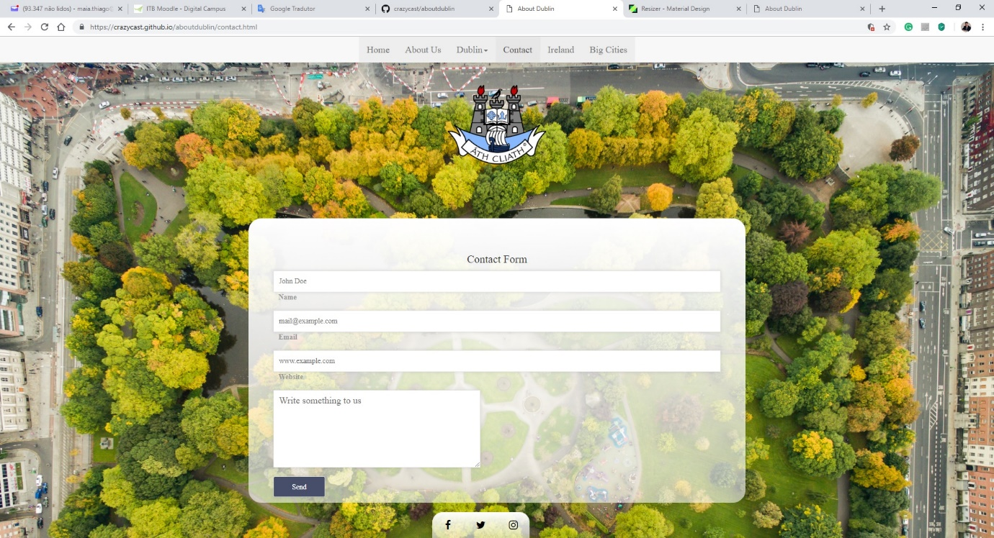

# <https://crazycast.github.io/aboutdublin/ireland.html>

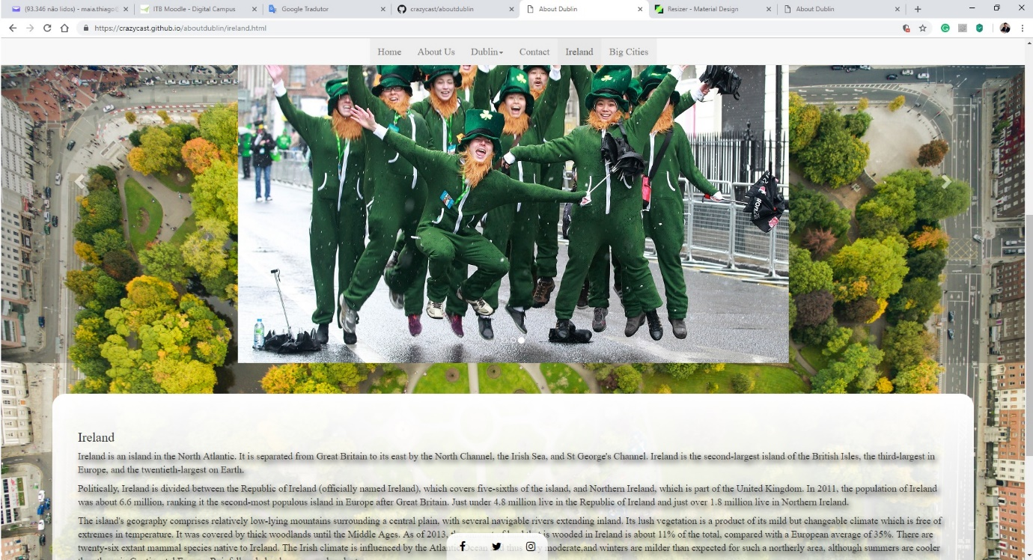

# <https://crazycast.github.io/aboutdublin/cities.html>

